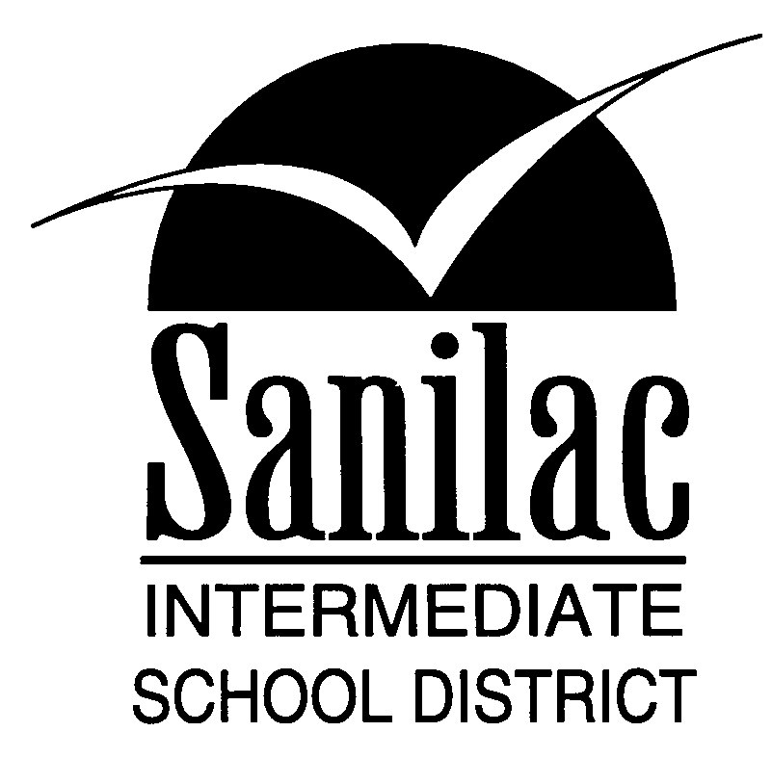
Special Education Services
46 North Jackson Street
Sandusky, Michigan 48471
810-648-2200

Date

Dear Parent/Eligible Student:

Please consider this letter as notification that _____________________________________________
School District

no longer is in need of the special education records for ____________________________________
Name
which are on file with our district. As special education services are no longer provided, these records may be destroyed. You need to be informed, however, that there may be a possible need for these records for such future purposes as social security benefits or other action. In addition, records should not be destroyed while the student is still in school.

A permanent record shall be maintained, without a time limitation, of the student containing the following data: 1) legal name/any other name, 2) sex, 3) birth date, 4) name of parents/legal guardians, 5) address, 6) date of entry, 7) date of withdrawal and reason, 8) name of school/school system to which student either transferred to or was transferred from, 9) subjects taken with applicable marks, 10) GED test results, 11) copy of work permit and/or deviations, if any,
12) work/school training contracts, if any.

_________________________________ education records will be kept on file in our district office
Student’s Name

until ___________________________. Unless we hear from you by the given date, our district will
Date
assume that you agree with the proposed destruction of records and have no further need for information contained in the file.

If there are any questions or concerns please contact me at _____________________________.
Phone Number

Thank you for your consideration.

____________________________________________________________________________________

Name School District

____________________________________________________________________________________
Address

